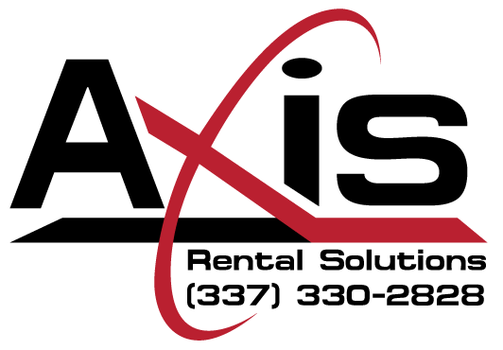

Hurricane Policy Notice

In an effort to protect the property and personnel associated either directly or indirectly related to Axis Rental Solutions, LLC., This Hurricane Policy Notice has been formulated and adopted and shall henceforth become an addendum of all Axis Rental Solutions Rental Agreements effective April 1, 2019.

Landfall Predictions – All landfall predictions shall based upon the forecasts and predictions of the National Weather Service’s National Hurricane Center. The latest information may be gathered from the official National Weather Service’s official website at www.nhc.noaa.gov.

Axis Rental Solutions Phases of Preparedness

- Phase I – In the event that a tropical cyclone (either hurricane of tropical storm) is expected to make landfall within seventy-two hours within the geographical region of the gulf coast ranging from Key West, Florida to Brownsville, Texas, Phase I of the Axis Rental Solutions Phases of Preparedness shall commence. Axis Rental Solutions, LLC shall field notifications for the retrieval and reception of equipment from all clients. Retrieval of equipment shall be based upon a “first call / first serve” basis utilizing all trucking assets owned by Axis Rental Solutions, LLC. During Phase I, all Axis Rental Solutions employees shall be on hand to assist with equipment pick-ups and reception of equipment at our main facility. Equipment may be returned to the Axis Rental Solutions, LLC main facility by third party trucking at the sole expense of the customer.

- Phase II – At such time as landfall of a tropical cyclone (hurricane or tropical storm) is forecast to make landfall within the geographical region of the gulf coast ranging from Key West, Florida to Brownsville, Texas, Phase II of the Axis Rental Solutions Phases of Preparedness shall commence. Upon initiation of Phase II, Axis Rental Solutions shall cease its operations to retrieve rental equipment but shall continue to receive equipment at its main location. Our main facility shall remain adequately staffed to accept all deliveries throughout Phase II. All equipment not returned to our main facility shall remain “On Rent” throughout the duration of the event and shall be taken “Off Rent” only upon return to Axis Rental Solutions at its main location in Houma, La.

- Phase III – In the event that any official government agency which has jurisdiction over any geographical region that affects the operations of Axis Rental Solutions, LLC., (e.g. – mandatory evacuation), Axis Rental Solutions shall cease all retrieval and receiving operations at its main facility. All equipment not returned to our main facility shall remain “On Rent” throughout the duration of the event and shall be taken “Off Rent” only upon return to Axis Rental Solutions at its main location in Houma, La. Additionally, all equipment not returned to Axis Rental Solutions LLC’s main facility either by Axis Rental Solutions delivery vehicles or third party trucking at the commencement of Phase III shall remain the responsibility of the client. Client shall remain fully responsible for all damages and lost equipment for the full duration of the contract. If such loss or damages occur, the customer shall be fully responsible for all repair costs or the full replacement cost of the equipment. Phase III of the Axis Rental Solutions Phases of Preparedness shall terminate immediately upon the return of Axis Rental Solutions, LLC employees, all necessary utilities have been restored, roadways are deemed clear and safe and the facility is deemed operable.
We realize that our equipment may be needed either during or in the aftermath of such an event. However, all rentals shall be subject to the standard terms and conditions of Axis Rental Solutions, LLC’s rental agreement (in addition to this Hurricane Policy). Due to the demand of governmental agencies for our equipment and first responders, reservations for equipment or right of refusal shall not be accepted by Axis Rental Solutions, LLC.

At Axis Rental Solutions, LLC, we are committed not only to the services we provide but most importantly to the safety of our employees and all personnel associated with the daily operations that support our industry and governmental agencies. Axis Rental Solutions, LLC apologizes in advance for any inconveniences this policy may cause.

